Advocacy support  - POhWER support centre can be contacted via 0300 456 2370  - Advocacy People gives advocacy support on 0330 440 9000  - Other advocates and links can be found on the PHSO webpage – https://www.ombudsman.org.uk/making-complaint/getting-advice-and-support  Further action  If you are dissatisfied with the outcome of your complaint then you can escalate your complaint to the Parliamentary Health Service Ombudsman (PHSO) at:  Milbank Tower, Milbank  LONDON  SW1P 4QP  Tel: 0345 015 4033  www.ombudsman.org.uk | Measham Medical Unit  High Street  Measham  Swadlincote  Derbyshire DE12 7HR  01530 270667 measham.doctors@nhs.net |  | The Complaints Process    - Measham Medical Unit  
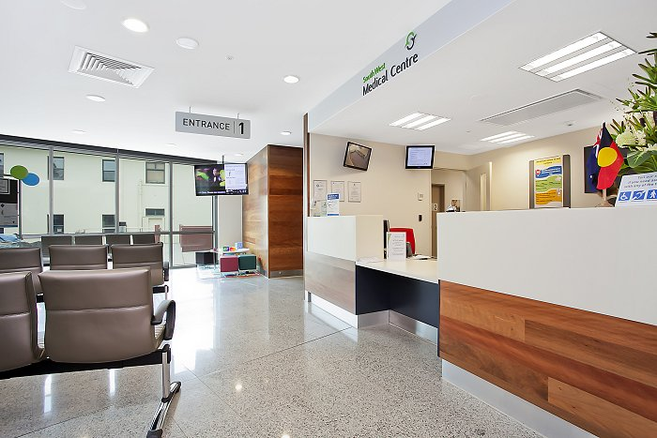  Talk to us  Every patient has the right to make a complaint about the treatment or care they have received at Measham Medical Unit.  We understand that we may not always get everything right and, by telling us about the problem you have encountered, we will be able to improve our services and patient experience.  Who to talk to  Most complaints can be resolved at a local level. Please speak to a member of staff if you have a concern and they will assist you where possible. Alternatively, ask to speak to the Practice Manager, Tracy Parker, but note this may need to be a booked appointment.  If for any reason you do not want to speak to a member of our staff, then you can request that the Integrated Care Board (ICB) investigates your complaint. They will contact us on your behalf: | Corporate Governance Team  NHS Leicester, Leicestershire and Rutland Integrated Care Board (ICB)  Room G30, Pen Lloyd Building  County Hall, Glenfield  Leicester LE3 8TB  0116 295 3405  llricb-llr@complaints@nhs.net  A complaint can be made verbally or in writing. A complaints form is available from Reception. Additionally, you can complain via email to measham.doctors@nhs.net  Time frames for complaints  The time constraint on bringing a complaint is 12 months from the occurrence giving rise to the complaint, or 12 months from the time you become aware of the matter about which you wish to complain.  We will respond to you within three business days to acknowledge your complaint.  We will aim to investigate and provide you with the findings as soon as we can and will provide regular updates regarding the investigation of your complaint  Acknowledging your complaint  We will acknowledge all complaints within 3 working days of receiving them. This includes Data Protection Complaints which patients should make to the practice in the first instance. |  | Investigating complaints  We will investigate all complaints effectively and in conjunction with extant legislation and guidance.  Confidentiality  We will ensure that all complaints are investigated with the utmost confidentiality and that any documents are held separately from the patient’s healthcare record.  Third party complaints  We allow third parties to make a complaint on behalf of a patient. The patient must provide consent for them to do so. A third-party patient complaint form is available from Reception.  Final response  We will issue a final formal response to all complainants which will provide full details and the outcome of the complaint. We will liaise with you about the progress of any complaint.

